- Object:
An object in Java is the physical as well as a logical entity, whereas, a class in Java is a logical entity only.
An object has three characteristics:

State: represents the data (value) of an object.
Behavior: represents the behavior (functionality) of an object such as deposit, withdraw, etc.
Identity: An object identity is typically implemented via a unique ID. The value of the ID is not visible to the external user. However, it is used internally by the JVM to identify each object uniquely.

- Ways to initialize object
There are 3 ways to initialize object in Java.

By reference variable
By method
By constructor

- There are many ways to create an object in java. They are:

1)By new keyword
2)By newInstance() method
3)By clone() method
4)By deserialization
5)By factory method etc

- Anonymous object:
Anonymous simply means nameless. An object which has no reference is known as an anonymous object. It can be used at the time of object creation only.
If you have to use an object only once, an anonymous object is a good approach. For example:
Example: New Calculation();
// Calling methods through Anonymous Object
New Calculation.sum();

- An object Is an instance of a class. A class is a template or blueprint from which objects are created. So, an object is the instance(result) of a class.

Difference between object and class
There are many differences between object and class. A list of differences between object and class are given below:
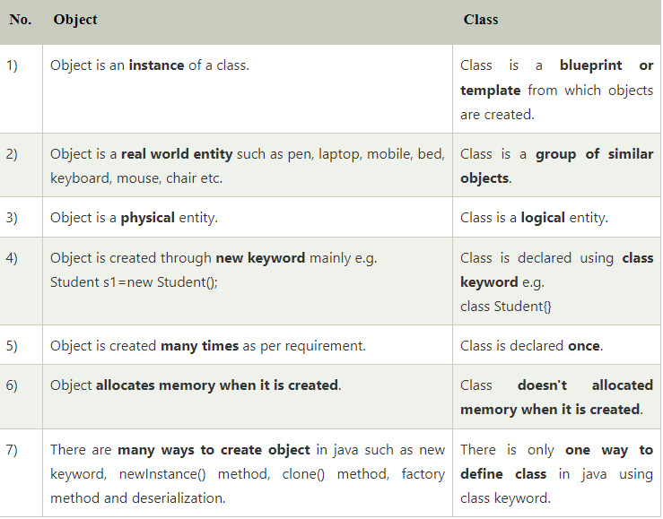

- New Keyboard:
The new keyword is used to allocate memory at runtime. All objects get memory in Heap memory area.

- Difference between constructor and method in Java
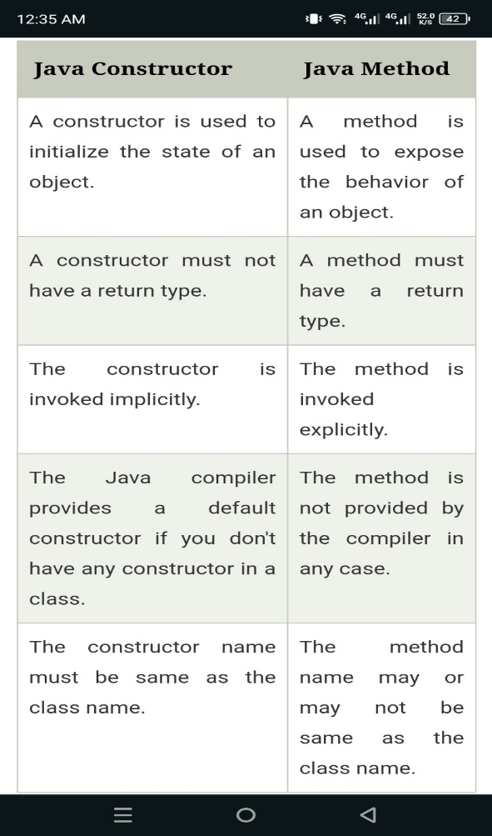

- Copy Constructor :

Ex: Student6(Student6 s){
Id = s.id;
Name =s.name;
}
Copy Constructor is used to copy the values of one instance to another.

- Java static keyword
The static keyword in Java is used for memory management mainly. We can apply static keyword with variables, methods, blocks and nested classes. The static keyword belongs to the class than an instance of the class.

The static can be:

Variable (also known as a class variable)
Method (also known as a class method)
Block
Nested class

Advantages of static variable:
Memory Management (takes memory only one time).

2) Java static method
If you apply static keyword with any method, it is known as static method.

A static method belongs to the class rather than the object of a class.
A static method can be invoked without the need for creating an instance of a class.
A static method can access static data member and can change the value of it.

Restrictions for the static method:

- The static method can not use non static data member or call non-static method directly.
- This and super cannot be used in static context.

3) Java static block:
Is used to initialize the static data member.
It is executed before the main method at the time of classloading.

Inheritance in Java:
Inheritance in Java is a mechanism in which one class acquires all the properties and behaviors of a parent object. It is an important part of OOPs (Object Oriented programming system).
The extends keyword indicates that you are making a new class that derives from an existing class. The meaning of “extends” is to increase the functionality.

In the terminology of Java, a class which is inherited is called a parent or superclass, and the new class is called child or subclass.

Method Overriding in Java
If subclass (child class) has the same method as declared in the parent class, it is known as method overriding in Java.

In other words, If a subclass provides the specific implementation of the method that has been declared by one of its parent class, it is known as method overriding.

Usage of Java Method Overriding:
Method overriding is used to provide the specific implementation of a method which is already provided by its superclass.
Method overriding is used for runtime polymorphism

Rules for Java Method Overriding:
The method must have the same name as in the parent class
The method must have the same parameter as in the parent class.

Why can we not override static method?
It is because the static method is bound with class whereas instance method is bound with an object. Static belongs to the class area, and an instance belongs to the heap area.

Instance initializer block:
Instance Initializer block is used to initialize the instance data member. It run each time when object of the class is created.

Example:
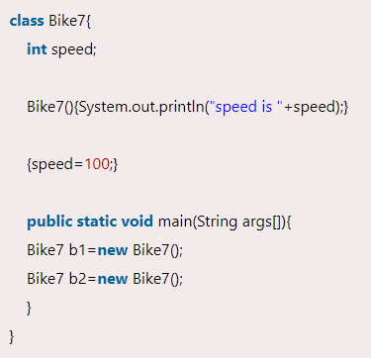
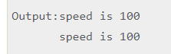

- Instance intializer block is invoked at the time of object creation. The java compiler copies the instance initializer block in the constructor after the first statement super(). So firstly, constructor is invoked. Let's understand it by the figure given below:
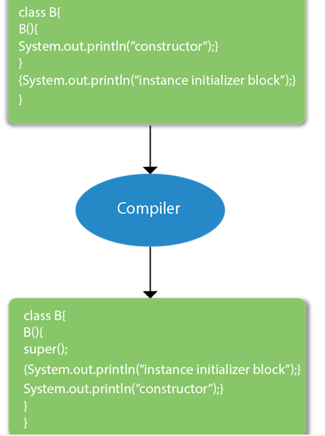

Rules for instance initializer block :
There are mainly three rules for the instance initializer block. They are as follows:
- The instance initializer block is created when instance of the class is created.
- The instance initializer block is invoked after the parent class constructor is invoked (i.e. after super() constructor call).
- The instance initializer block comes in the order in which they appear.
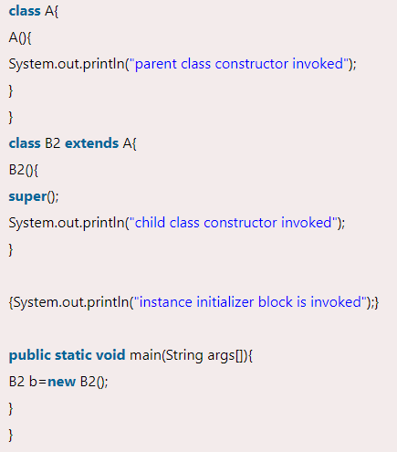
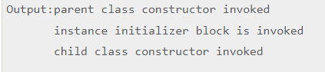

Final Keyword In Java:
The final keyword in java is used to restrict the user. The java final keyword can be used in many context. Final can be:
- variable
- method
- class
The final keyword can be applied with the variables, a final variable that have no value it is called blank final variable or uninitialized final variable. It can be initialized in the constructor only. The blank final variable can be static also which will be initialized in the static block only

1) Java final variable
If you make any variable as final, you cannot change the value of final variable(It will be constant).

2) Java final method
If you make any method as final, you cannot override it.

3) Java final class
If you make any class as final, you cannot extend it.

Q) Is final method inherited?
Ans) Yes, final method is inherited but you cannot override it.

Que) Can we initialize blank final variable?
Yes, but only in constructor.

static blank final variable
A static final variable that is not initialized at the time of declaration is known as static blank final variable. It can be initialized only in static block.
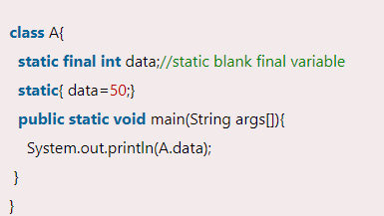

Q) What is final parameter?
If you declare any parameter as final, you cannot change the value of it.
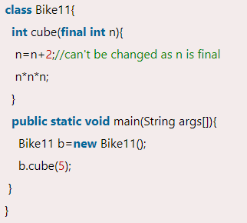

Java Runtime Polymorphism with Data Member
A method is overridden, not the data members, so runtime polymorphism can't be achieved by data members.
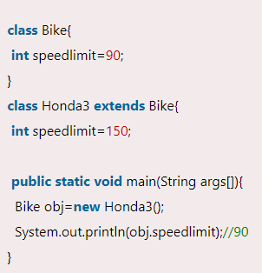
Output: 90

Polymorphism in Java
Polymorphism in Java is a concept by which we can perform a single action in different ways.
There are two types of polymorphism in Java: compile-time polymorphism and runtime polymorphism. We can perform polymorphism in java by method overloading and method overriding. if you overload a static method in Java, it is the example of compile time polymorphism.

Runtime Polymorphism in Java
Runtime polymorphism or Dynamic Method Dispatch is a process in which a call to an overridden method is resolved at runtime rather than compile-time.

Upcasting
If the reference variable of Parent class refers to the object of Child class, it is known as upcasting.

Static Binding and Dynamic Binding:
- Static Binding (also known as Early Binding).
- Dynamic Binding (also known as Late Binding).

static binding
When type of the object is determined at compiled time(by the compiler), it is known as static binding.
If there is any private, final or static method in a class, there is static binding.
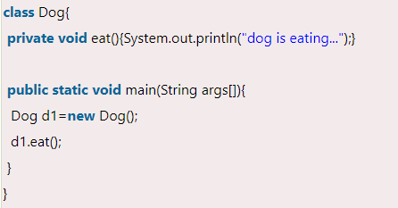

Dynamic binding
When type of the object is determined at run-time, it is known as dynamic binding.
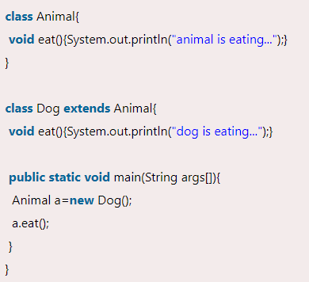

Java instanceof:
The java instanceof operator is used to test whether the object is an instance of the specified type (class or subclass or interface).

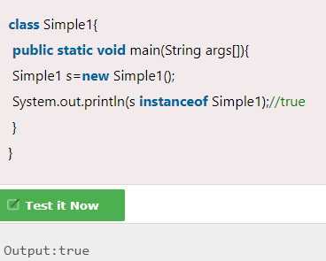

An object of subclass type is also a type of parent class. For example, if Dog extends Animal then object of Dog can be referred by either Dog or Animal class.
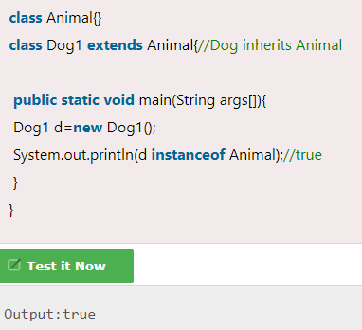

instanceof in java with a variable that have null value
If we apply instanceof operator with a variable that have null value, it returns false.
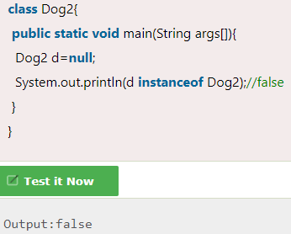

Abstract class in Java:
A class which is declared with the abstract keyword is known as an abstract class in Java. It can have abstract and non-abstract methods (method with the body).
A class which is declared as abstract is known as an abstract class. It can have abstract and non-abstract methods. It needs to be extended and its method implemented. It cannot be instantiated.

There are two ways to achieve abstraction in java
- Abstract class (0 to 100%)
- Interface (100%)

Points to Remember:
- An abstract class must be declared with an abstract keyword.
- It can have abstract and non-abstract methods.
- It cannot be instantiated.
- It can have constructors and static methods also.
- It can have final methods which will force the subclass not to change the body of the method.

Abstract Method in Java:
A method which is declared as abstract and does not have implementation is known as an abstract method.

Abstract class having constructor, data member and methods:

An abstract class can have a data member, abstract method, method body (non-abstract method), constructor, and even main() method.

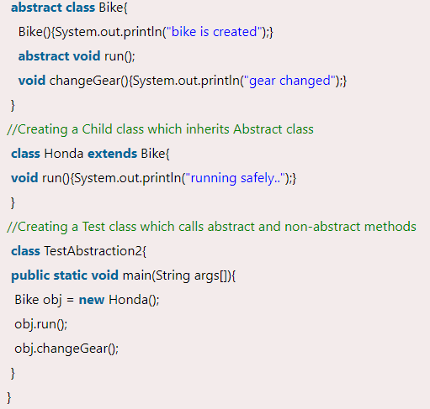
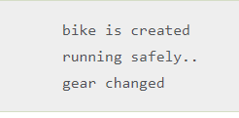

Rule: If there is an abstract method in a class, that class must be abstract.

Rule: If you are extending an abstract class that has an abstract method, you must either provide the implementation of the method or make this class abstract.

Interface in Java:
An interface in Java is a blueprint of a class. It has static constants and abstract methods.
The interface in Java is a mechanism to achieve abstraction. It is used to achieve abstraction and multiple inheritance in Java.

Why use Java interface?
There are mainly three reasons to use interface.
- It is used to achieve abstraction.
- By interface, we can support the functionality of multiple inheritance.
- It can be used to achieve loose coupling.

The Java compiler adds public and abstract keywords before the interface method. Moreover, it adds public, static and final keywords before data members.

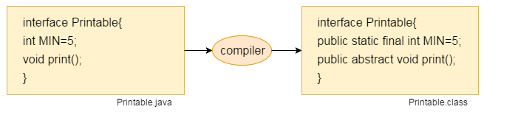

The relationship between classes and interfaces:
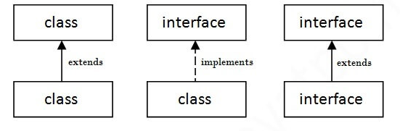

Multiple inheritance in Java by interface
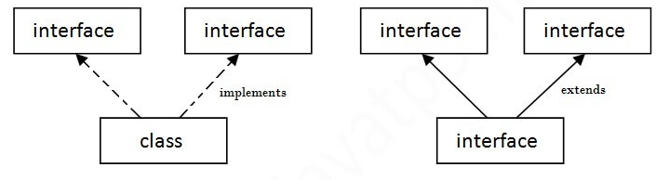

Interface inheritance:
A class implements an interface, but one interface extends another interface.

Static Method in Interface:
Since Java 8, we can have static method in interface. Let's see an example:
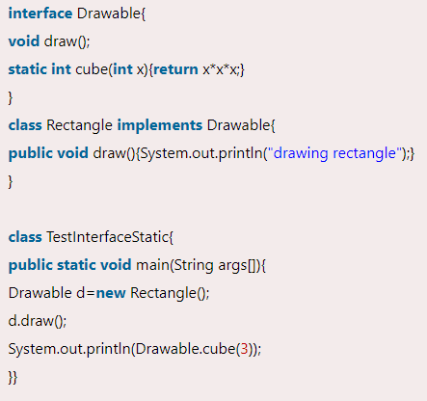

Difference between abstract class and interface
Abstract class and interface both are used to achieve abstraction where we can declare the abstract methods. Abstract class and interface both can't be instantiated.
But there are many differences between abstract class and interface that are given below.
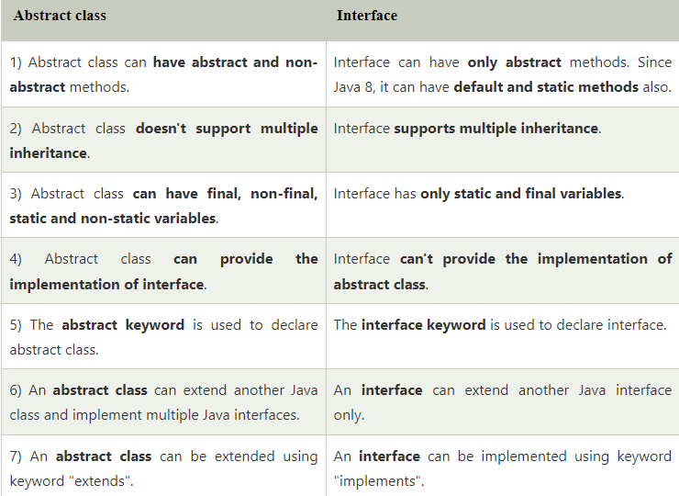
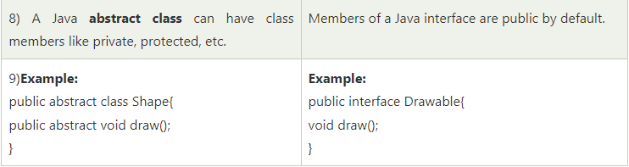

Access Modifiers in Java
There are two types of modifiers in Java: access modifiers and non-access modifiers.
There are four types of Java access modifiers:
- Private: The access level of a private modifier is only within the class. It cannot be accessed from outside the class.
- Default: The access level of a default modifier is only within the package. It cannot be accessed from outside the package. If you do not specify any access level, it will be the default.
- Protected: The access level of a protected modifier is within the package and outside the package through child class. If you do not make the child class, it cannot be accessed from outside the package.
- Public: The access level of a public modifier is everywhere. It can be accessed from within the class, outside the class, within the package and outside the package.
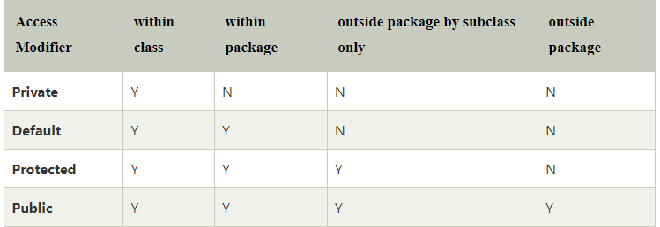

There are many non-access modifiers, such as static, abstract, synchronized, native, volatile, transient, etc.

Role of Private Constructor
If you make any class constructor private, you cannot create the instance of that class from outside the class. For example:
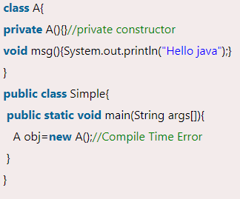

Note: A class cannot be private or protected except nested class.

Java Access Modifiers with Method Overriding:
If you are overriding any method, overridden method (i.e. declared in subclass) must not be more restrictive.

Encapsulation in Java:
Encapsulation in Java is a process of wrapping code and data together into a single unit, for example, a capsule which is mixed of several medicines. We can create a fully encapsulated class in Java by making all the data members of the class private. Now we can use setter and getter methods to set and get the data in it.
The Java Bean class is the example of a fully encapsulated class.
Advantage of Encapsulation in Java:
- It provides you the control over the data. Suppose you want to set the value of id which should be greater than 100 only, you can write the logic inside the setter method. You can write the logic not to store the negative numbers in the setter methods.
- It is a way to achieve data hiding in Java because other class will not be able to access the data through the private data members.
- The encapsulate class is easy to test. So, it is better for unit testing.

Object class in Java
The Object class is the parent class of all the classes in java by default. In other words, it is the topmost class of java.
The Object class is beneficial if you want to refer any object whose type you don't know. Notice that parent class reference variable can refer the child class object, know as upcasting.

Methods of Object class:
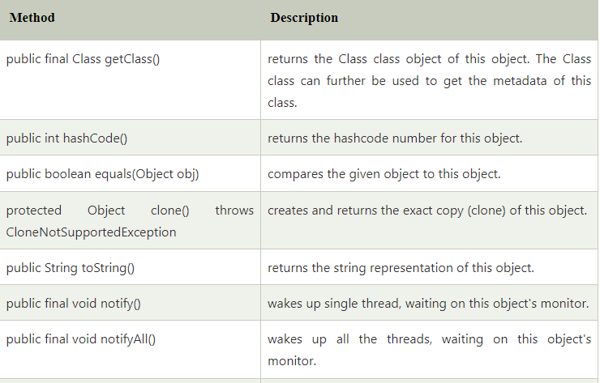
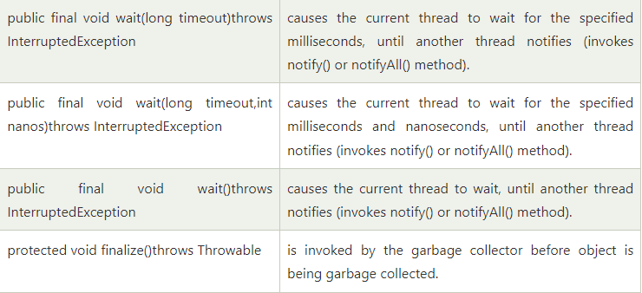

Call by Value and Call by Reference in Java
There is only call by value in java, not call by reference. If we call a method passing a value, it is known as call by value. The changes being done in the called method, is not affected in the calling method.

Example of call by value in java:
In case of call by value original value is not changed. Let's take a simple example

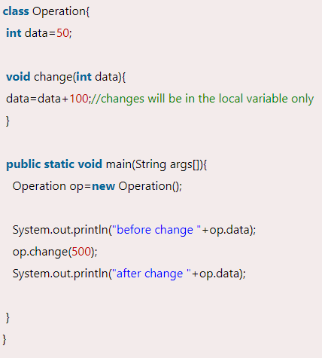
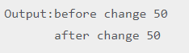

Another Example of call by value in java:
In case of call by reference original value is changed if we made changes in the called method. If we pass object in place of any primitive value, original value will be changed. In this example we are passing object as a value. Let's take a simple example:

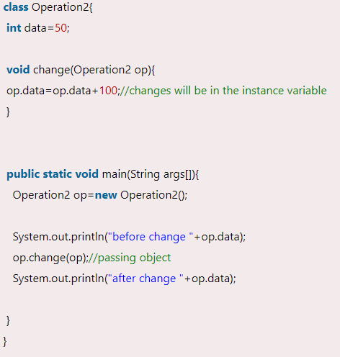
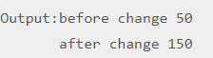

Difference between method overloading and method overriding in java

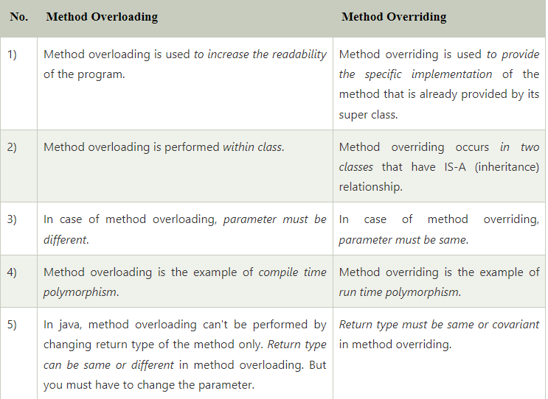

Exception Handling in Java

The Exception Handling in Java is one of the powerful mechanism to handle the runtime errors so that the normal flow of the application can be maintained.

What is Exception in Java?
In Java, an exception is an event that disrupts the normal flow of the program. It is an object which is thrown at runtime.

What is Exception Handling?
Exception Handling is a mechanism to handle runtime errors such as ClassNotFoundException, IOException, SQLException, RemoteException, etc.

Java Exception Keywords:
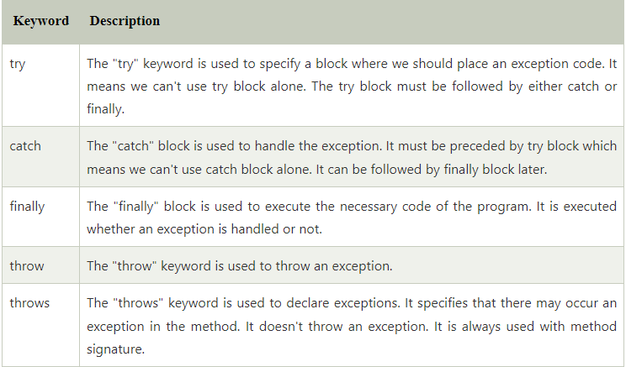

Java Exception Handling Example:

